1. Go to SE80
2. Create Function Group
3. Create Function Module

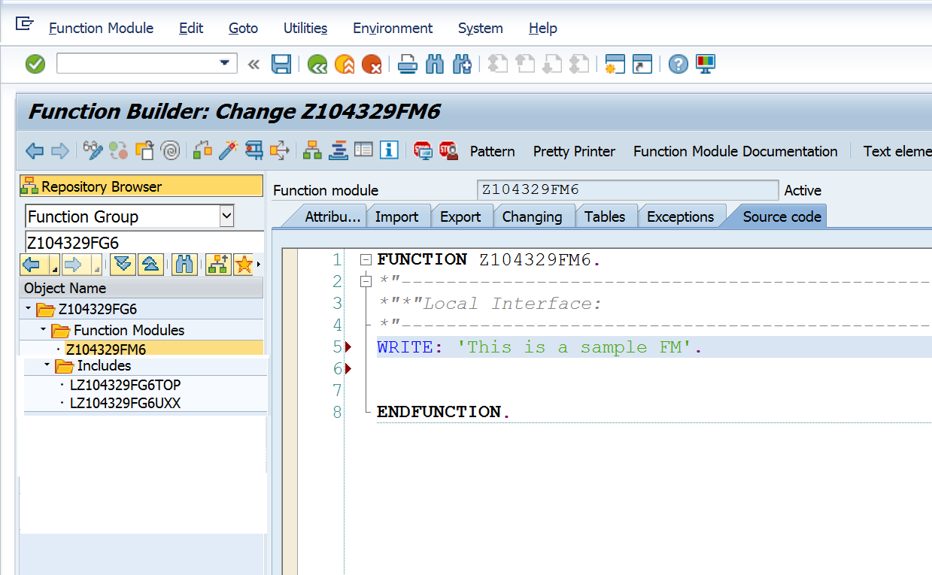

1. Call function module from SE38 program.